Chapter 13: Achieving Energy Sustainability

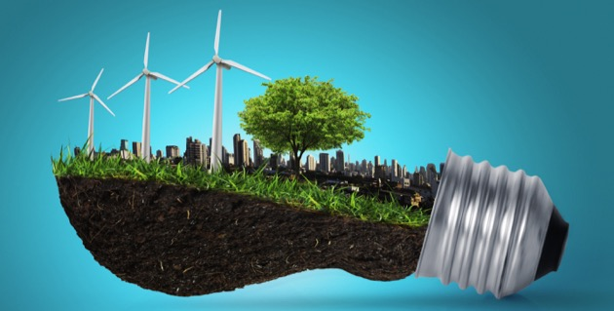

Can you….

1. Describe strategies to conserve energy and increase energy efficiency?
2. Explain differences among the various renewable energy resources?
3. Describe the various forms of biomass?
4. Explain how energy is harnessed from water?
5. List the different forms of solar energy and their application?
6. Describe how wind energy is harnessed and its contemporary uses?
7. Discuss the methods of harnessing the internal energy from Earth?
8. Explain the advantages and disadvantages of energy from hydrogen?
9. Discuss the environmental and economic options we must assess in planning our energy future?
10. Consider the challenges of a renewable energy strategy?